CS 340 Project 2 README

About the Project/Project Title
Our team for Global Rain has completed this project for our client Grazioso Salvare. We designed a python module to provide a convenient and user-friendly interface for performing CRUD (Create, Read, Update, Delete) operations on a MongoDB database.

Then we developed a dashboard to display the data in a table with filter options. Th dashboard provides buttons for filtering the results to the types of dogs perfect for training in specific rescues, a pie chart for seeing what percentage of each dog breed briefly, and a map to show the exact geolocation of where the dog can be adopted.

Motivation
The completion of this project will allow Grazioso Salvare to have an easier time sorting through the data to find the appropriate dogs to train and their location in the map feature.

Getting Started
To get started on using CRUD to manipulate the dataset, follow these simple example steps:
- Import Mongo CSV file containing all the data on the Linux Terminal
- Create an admin username and password for the data collection
- Instantiate the class in Python using the MongoDB credentials created(done in the Jupyter Notebook)

To start developing the interactive web application:
- Basic and compound indexes were created on relevant fields (e.g., breed, outcome_type) to improve query performance for the dashboard's filtering needs
- The initial Dash application was structured, incorporating HTML/CSS components via dash-html-components and dash-core-components
- Python callback functions were implemented to link the user input widgets (filters, table selection) with the data table, geolocation map, and pie chart.
**See screenshot section below for examples.

Installation
The main tool used in this project was Jupyter Notebook to develop python code and testing. We also used a Linux operating system to access the database itself. The MongoDB Python driver used in this module is pymongo. It is a mature and widely-used driver that offers a high-level API for interacting with MongoDB databases. pymongo is chosen for its ease of use, extensive documentation, and active community support. To install pymongo, if not already a part of the notebook, use the following pip command: pip install pymongo

The Dash Framework was used to create an interactive web application. Dash(Plotly) allows for the creation of interactive web-based dashboards entirely in Python and has access to to powerful graphing libraries. It provides the View and Controller structure for the app and manages user interactions via callbacks for clean/organized coding.

CRUD Usage
This code uses CRUD to manipulate the imported Animal Shelter data. You can perform the following operations in the “AnimalShelter” class:

- Create- Insert a document into the “animals” collection. Returns “True” if inserted and “False” if it failed to insert
- Read- Run a query for documents using find() operation. Return a list of matching results.
- Update- Run a query and update a document that matches with new values. Returns count of modified documents.
- Delete- Run a query and delete all documents that match it. Return count of deleted documents

Code Example
Python Code for CRUD functionality:
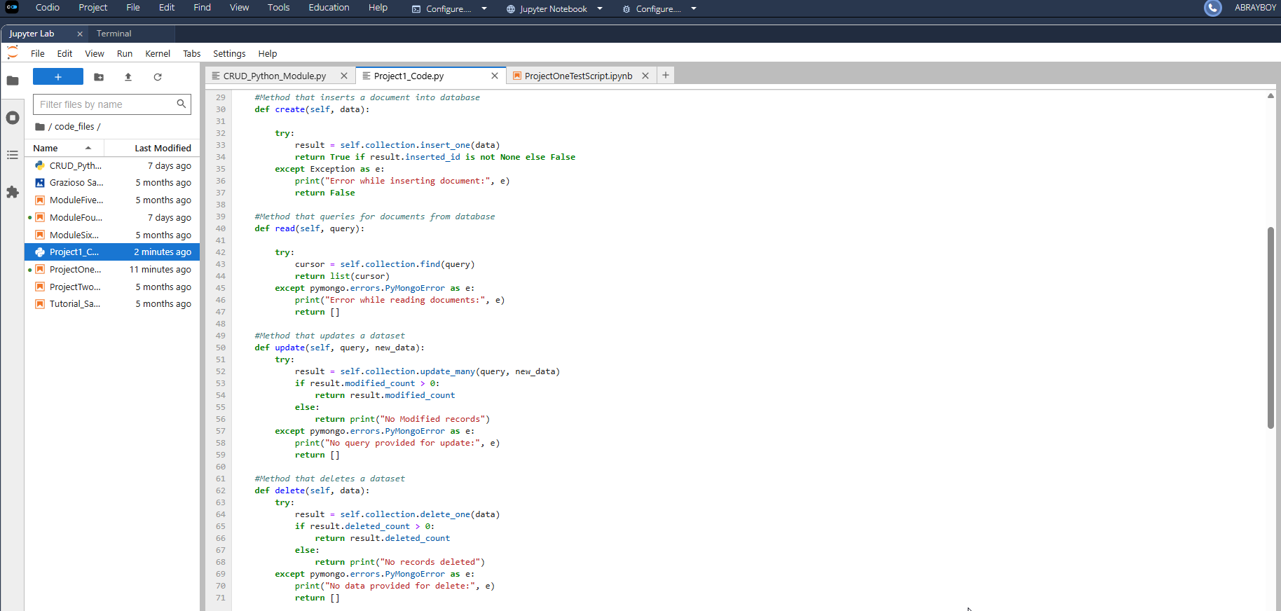

Tests
Test & Result for Creating new record
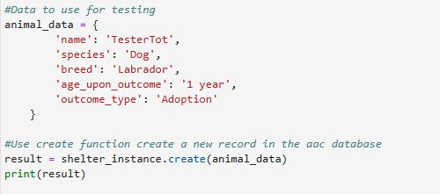

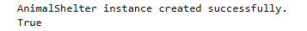

Test & Result for Reading query of existing record
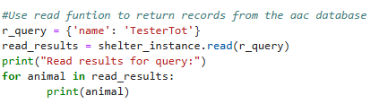

Test & Result for Updating existing record
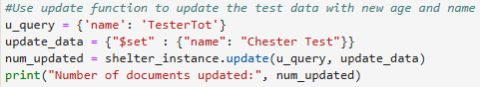

Test & Result for Deleting existing record

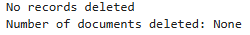
DASH Usage
The DASH code created a table to display the Animal Shelter Database in it’s entirety using HTML components that make it easier to read. We not only styled the table but also put in Mr. Salvare’s logo to brand the web app. We included features for easier management of the data, such as buttons to filter data to the specific dog types he needs, a pie chart for statistics, and a map showing where he can get any dog he selects from table. This is the results:
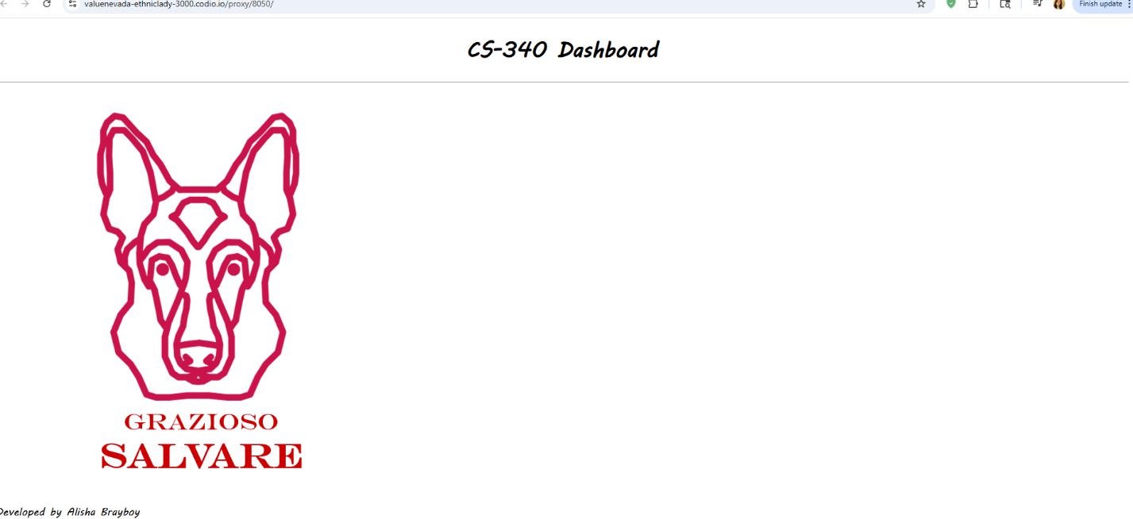

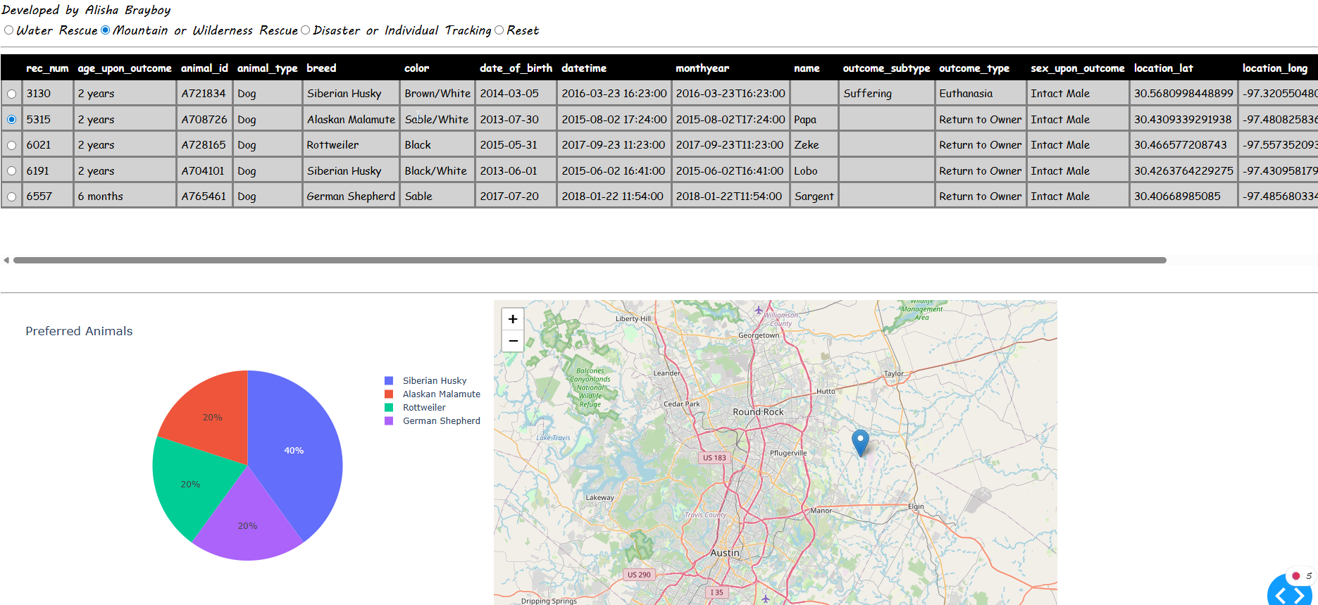

Screenshots for getting started

Import CSV file of the dataset:
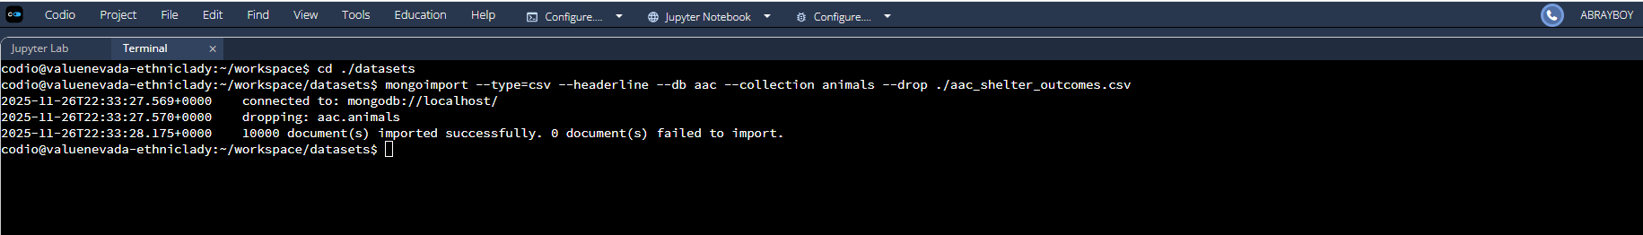

Create Admin User Account for collection:
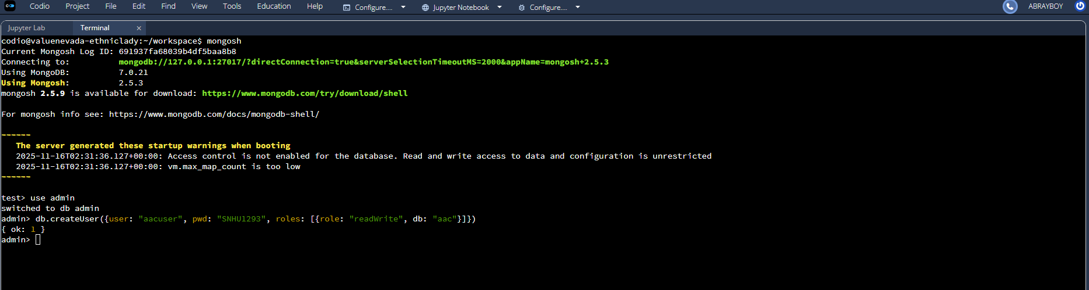

Python Code to instantiate the class in Python and initialize the connection:
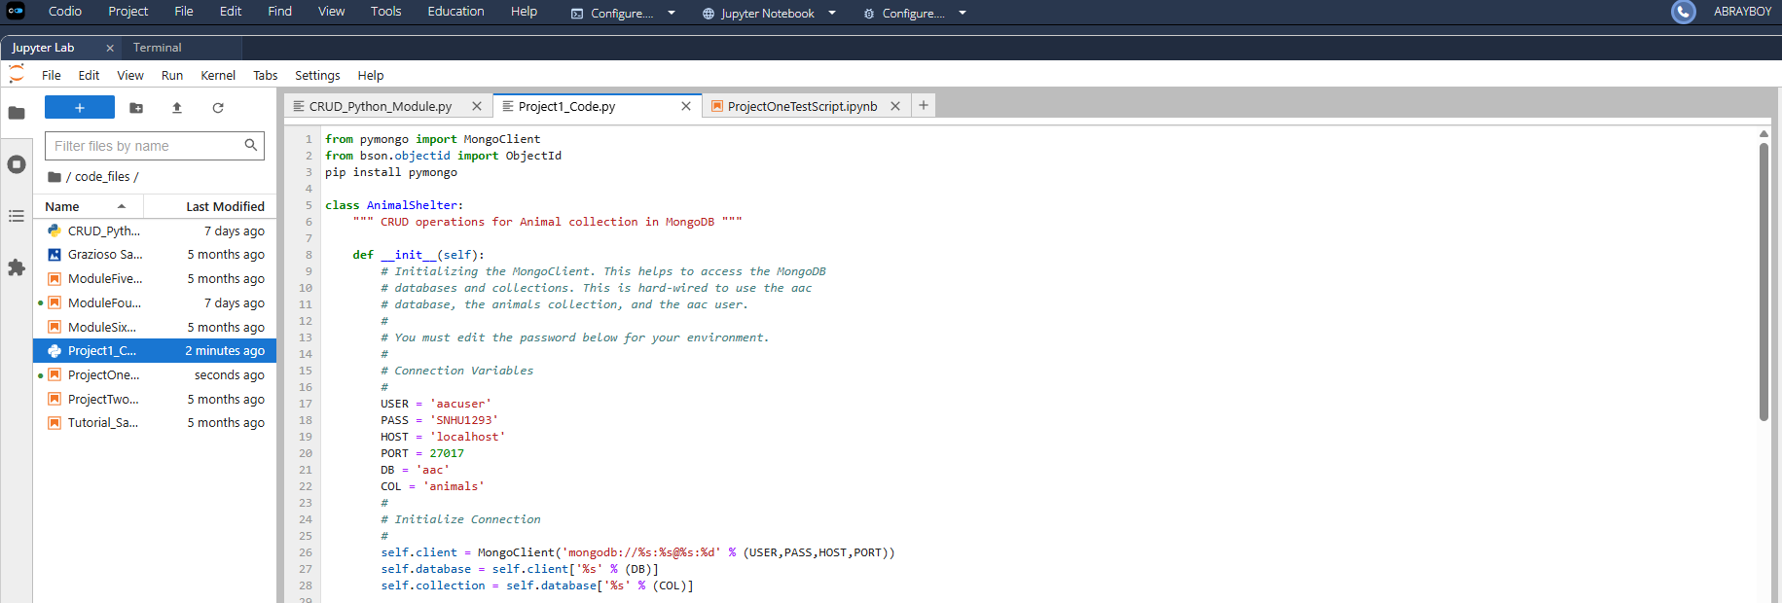

DASH code for Indexing:
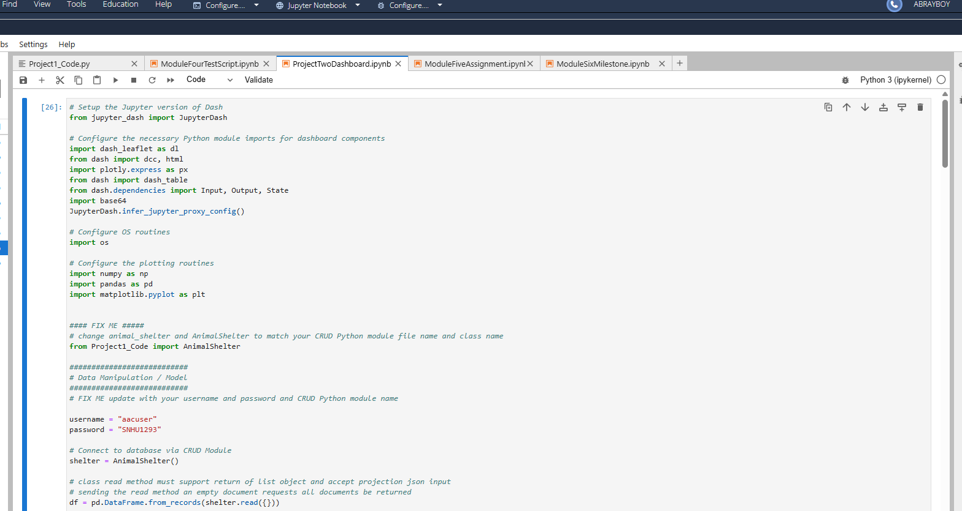

DASH code for HTML/CSS components:
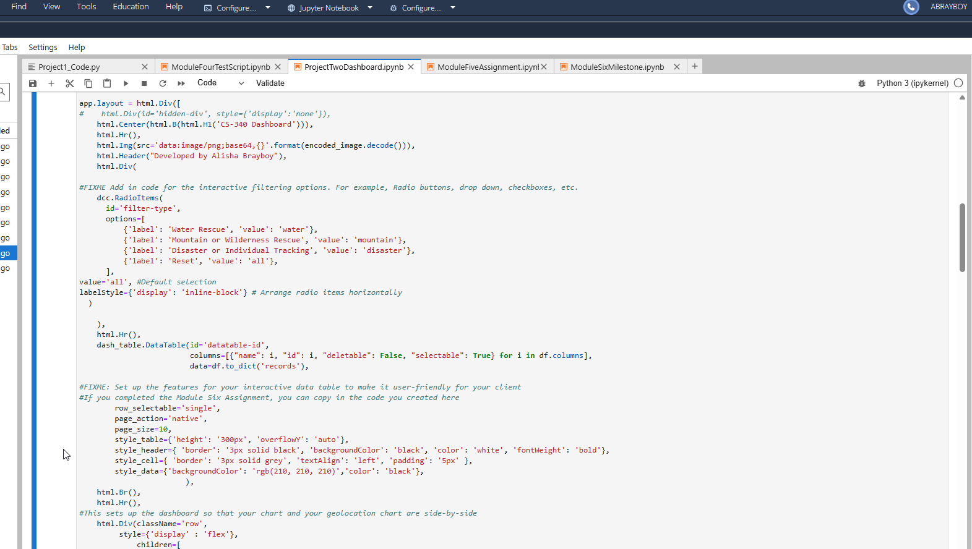

DASH code for Callbacks:
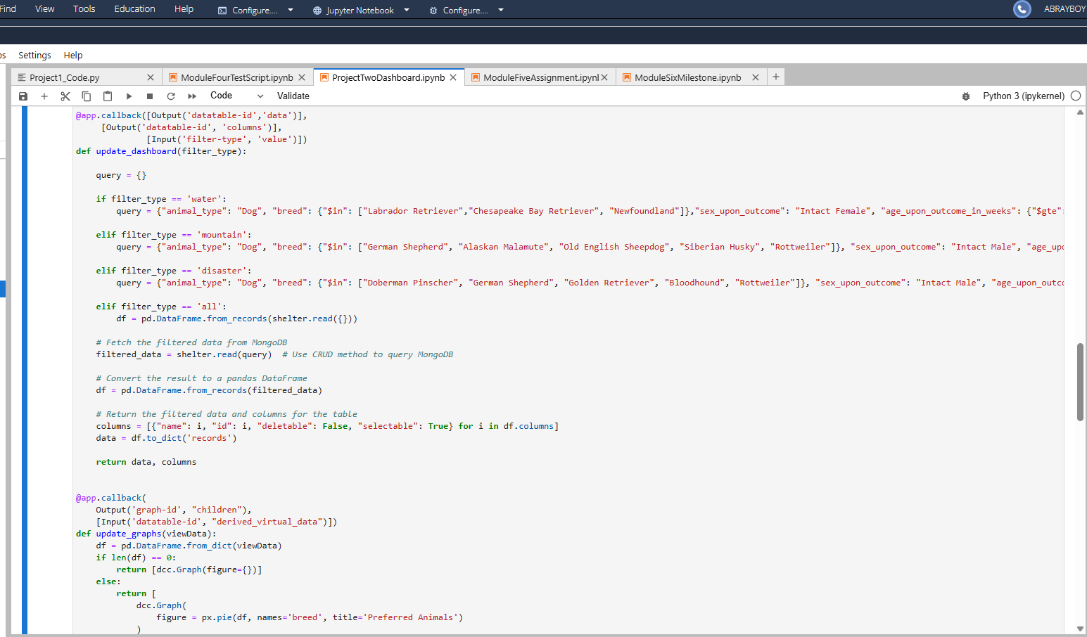
Challenges Encountered and Solutions
My biggest challenge was understanding the Dash Callbacks for filtering the data and returning it. I worked and reworked the code dozens of times in the update_dashboard class and failed almost everytime. The table in the web app just wouldn’t filter. After many tries I thought the issue might be I was trying to find specific results while fetching the results from MongoDB at the same time.
I resolved this by consulting official documentation and tutorials, clarifying how components and interactions connect. Then I created 2 new variables, one to specify the filtered results I wanted: (query), and one to hold those specifications when using my CRUD code and reading from MongoDB: (filtered_data). Then I could use the filtered_data variable, which held the results much easier, to convert the needed data into the pandas dataframe for creating the new table that was returned.

Contact
Your name: Alisha Brayboy
Email: alisha.brayboy@snhu.edu
Phone: 571-584-3071

